PICTURE _Group Photo | Enhancing Gender Inclusive Public Procurement and Open Contracting in Malawi.  More Opportunities, Fairer Access. Strong women led businesses.  The National Association of Business Women (NABW) is implementing this project with support from the Women and Girls Fund (WGF), financed by the Scottish Government and managed by Ecorys UK and FAWEMA. The project works to remove barriers and promote gender-responsive public procurement so that women led businesses in Malawi can access, compete for and benefit government contracts.
Picture of Women in Training | Project Overview  Creating Equal Opportunities for Women in Public Procurement  A more inclusive, transparent and accessible procurement system for Malawi  Public procurement presents significant opportunities for business growth, job creation and economic empowerment. However, many women-led businesses in Malawi remain underrepresented in government contracting due to persistent structural, institutional and capacity-related barriers.  Women entrepreneurs often face challenges such as limited access to procurement information, complex tendering procedures, inadequate financial and technical capacity, limited awareness of preferential procurement provisions, and difficulties navigating electronic procurement systems. Other concerns include unfair competition, corruption, sexual harassment and exploitation, and delayed payments, which further discourage women's participation.  Our three focus areas  Visual Card 1  Policy advocacy  Influencing inclusive policies and institutional practices  Visual Card 2  Women's empowerment  Building procurement knowledge, readiness and skills  Visual Card 3  Transparency and accountability  Promoting open contracting and fair procurement
PICTURE | 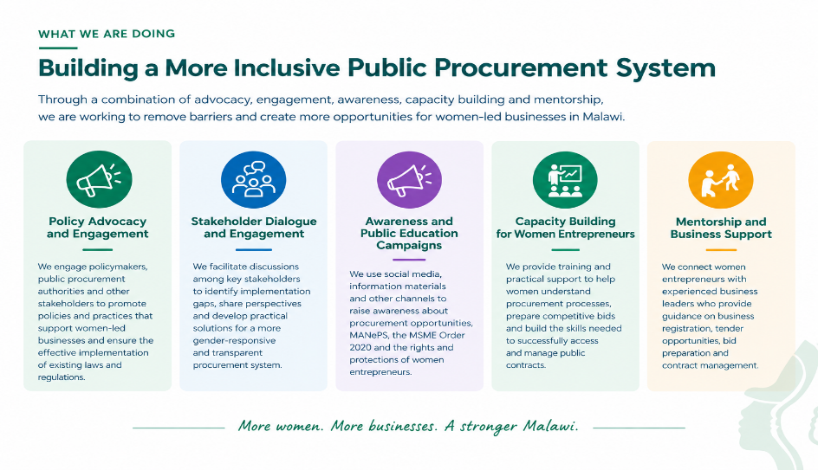
Pictures | 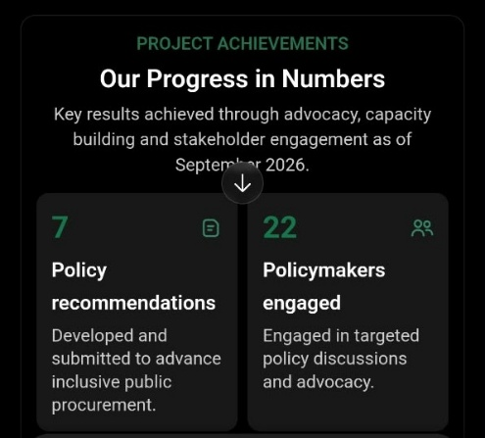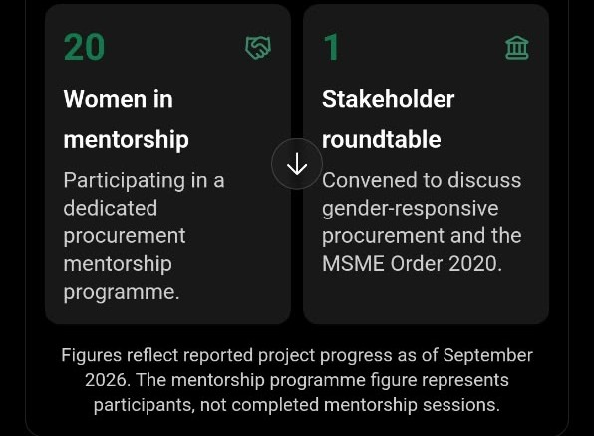  PROJECT ACHIEVEMENTS  Our Progress in Numbers  Key results achieved through advocacy, capacity building and stakeholder engagement as of September 2026.  7 Policy recommendations  Developed and submitted to advance inclusive public procurement.  22Policymakers engaged  Engaged in targeted policy discussions and advocacy.  56Women entrepreneurs trained  Equipped with knowledge and skills to participate in public procurement.  4Advocacy engagements  Conducted to promote gender-responsive procurement practices.  1 Policy brief  Developed and disseminated to inform policy dialogue.  11 Campaign materials  Eight awareness posters and three advocacy videos developed.  20Women in mentorship  Participating in a dedicated procurement mentorship programme.  1 Stakeholder roundtable  Convened to discuss gender-responsive procurement and the MSME Order 2020.  Figures reflect reported project progress as of September 2026. The mentorship programme figure represents participants, not completed mentorship sessions.
Impact and project gallery
Event photographs, relevant news stories and links to project publications or advocacy materials.

